**BASH Script to create repo in github**

*\*create API token on Github.*

*Github_account > settings > Developer_settings > Personal_access_tokens > Tokens_classic*

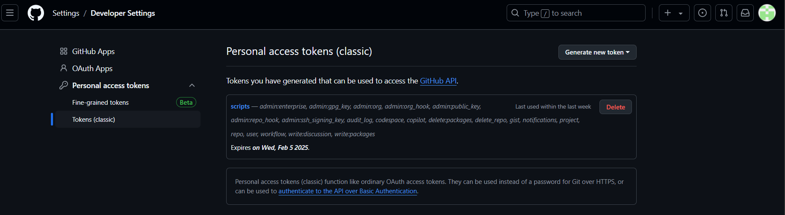

*\*Creating a file and adding script in it.*

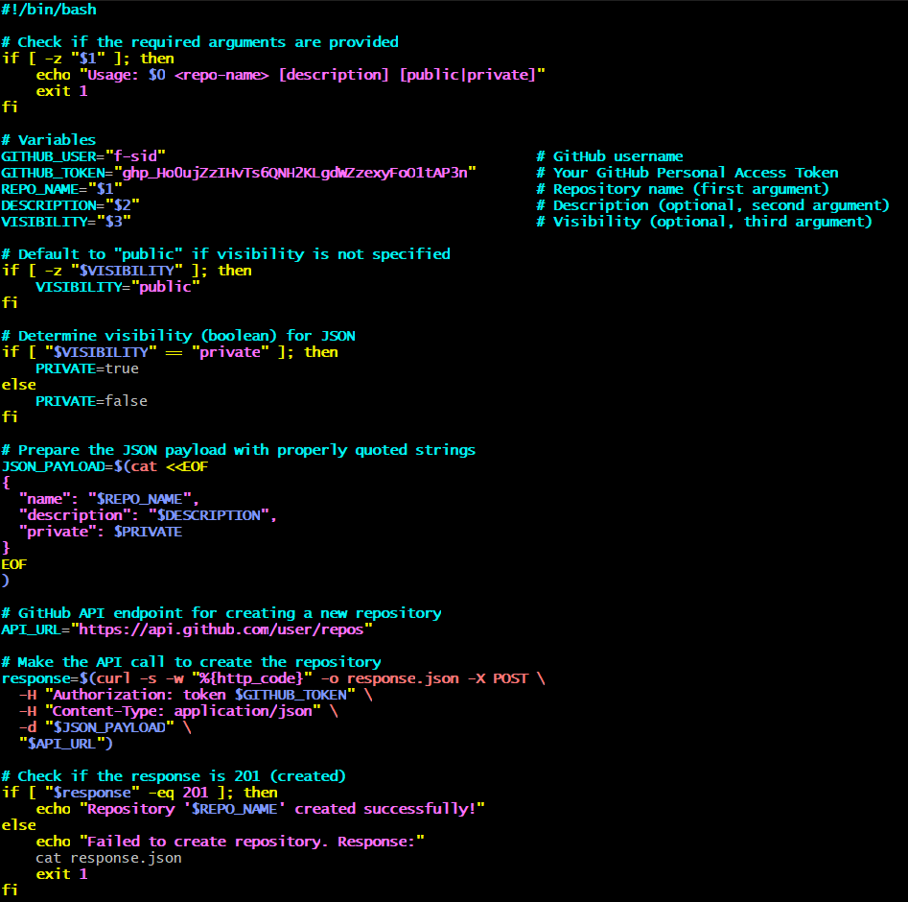

*\*Adding permissions and executing scripts*

*$chmod a+x filename*

*$./filename <repository_name> “description” <public/private>*

**

*\*Checking the github*

